**Reputation in the Ultimatum Game and the Evolution of Fairness**

Like many other games studied by economists and evolutionary game theorists, the Ultimatum Bargaining game yields experimental results that are radically different from the predicted analytical solutions.­ In versions structured like that depicted in Figure 1, solving the game by backwards induction, thereby following and assuming sequential rationality in others, leads to the proposer making an unfair offer and the responder accepting it. Accepting unfair offers yields strictly greater payoffs than rejecting them, leading one to expect, in many cases, universal acceptance of offers under simulated evolutionary dynamics or rational learning mechanisms, and, once this occurs, universal proposal of unfair offers becoming a stable attractor in the replicator dynamics.

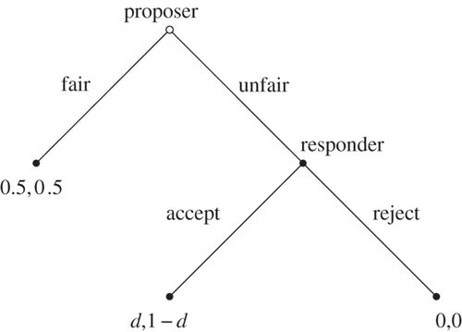

**Fig. 1:** Simplifiedultimatum bargaining game in extended form with abstracted, proportional payoffs.

The observed experimental behavior, however, is quite the opposite. The proposer generally makes fair or nearly fair offers, and the responder often rejects significantly unfair offers. This causes researchers to believe that subjects are adhering to some notion of justice and fairness that they seek to follow and/or enforce. W. Güth et al describe the considerations of the responder as follows: “If [the proposer] left a fair amount to me, I will accept. If not, and if I do not sacrifice too much, I will punish him by [rejecting the offer]”.1 Furthermore, among several different cultures, experimental research again shows no society-wide adherence to any strategy resembling the backwards induction solution, although significant variation is nevertheless observed.2 Why the responder’s thought process as conjectured by Güth exists and how it could have emerged as part of a fairness norm has not been fully explained in previous game-theoretical literature. We offer a reputation-based explanation for the emergence of fair proposals and sequentially irrational rejection of unfair proposals through the use of computer simulations of evolutionary replicator dynamics. Specifically, we find in these simulations that if proposers can react to the responder’s previous decision history when faced with unfair offers with sufficient probability, then the “fair-man” strategy becomes a universal attractor, matching the experimental observations with far greater accuracy than that predicted by rational decision theory.

Our base simulation without reputation operates with a world of agents who employ one of four strategy sets:

1. Easy Rider (propose fair, accept unfair)
2. Fairman (propose fair, reject unfair)
3. Gamesman (propose unfair, accept unfair)
4. Hypocrite (propose unfair, reject unfair)

Out of 10 units to be divided, we take a fair offer to be a 50-50 split and an unfair offer to be a 90-10 split in favor of the proposer. Rejection of an offer yields 0 utility for both players, and all fair offers are assumed to be accepted. Ultimatum possibilities are summarized in Figure 2.

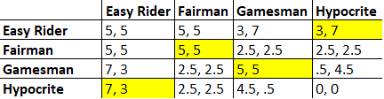

**Fig 2:** Payoff matrix of the four strategies considered. Average of two games, one played in each role. Pure strategy Nash equilibria are highlighted.

Agents play two games with a randomly chosen partner, one game in each role, and the total utility acquired from the games are added to that agent’s score. This can occur a specified number of times after which the next generation is created using the discrete replicator dynamics. Strategy sets that perform better than average will see greater representation in the next generation, and those that are worse will see less. The next generation is created with no memory of the previous (namely with regard to reputation as described later) and in theory remains the same size. However, due to the random pairing process, if there are an odd total number of agents (due to rounding), one agent is randomly deleted so pairing can continue smoothly.

Reputation scores are inserted as two ‘public’ pieces of data that accompany each agent: number of unfair offers received, and number of unfair offers accepted. Another global piece of data called the “reputation bias” is used, representing the probability that the proposer will look to the responder’s reputation for guidance rather than to his default proposal. If the proposer ultimately accounts for the responder’s reputation, he will do so with the following simulation. One “reject” and one “accept” labeled ball are placed in a bin, plus another “accept” ball for every offer the responder previously accepted and another “reject” ball for rejections (number of unfair offers received minus number accepted). One ball is chosen at random, and the proposer makes the offer best suited to the responder acting according to the chosen ball. This probabilistic response is summarized by $\frac{unfair offers accepted+1}{unfair offers received+2}$, as the probability that the proposer will make an unfair offer, given that he is looking to the responder’s reputation. This method is chosen because it offers an increasing reputational effect as more games are played and since it replicates a proposer’s potential take on the public perception of the responder rather than myopically assuming all proposers will uniformly and deterministically respond to the same reputation, thereby increasing the realism and explanatory power of the simulation.

To test the effects of the reputation score on the evolutionary behavior of the population we vary the reputation bias from 0.0 to 1.0 and plot the average proportions of the strategies at the end of each of 20 trials consisting of 100 generations with 5 rounds of paired games per generation. Initial populations consist of 100 agents employing each strategy. Results are summarized in Figures 3 and 4.

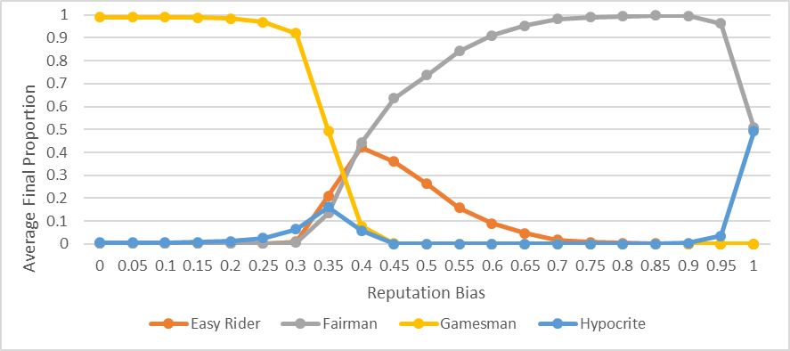

**Fig. 3:** Average proportions of each strategy after 100 generations.

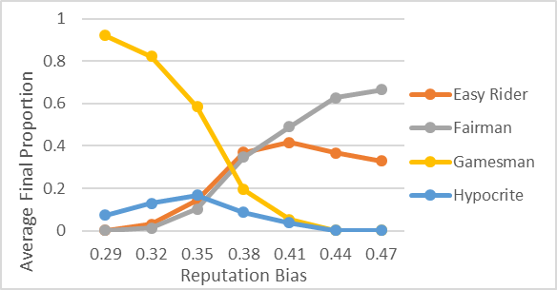

**Fig. 4:** Similar to Fig. 3, but focused on the region where Fairman overtakes Gamesman (not the same test run as Fig. 3, however).

Figure 3 demonstrates clearly the effect that reputation has on the evolutionary dynamics of the population. In our base case with a reputation bias (r) of zero, the equal proportioned population evolves according to the sequentially rational equilibria corresponding to all offers being accepted, and all proposals being unfair. While r < .3, the final population contains over 90% Gamesmen. However, from r = 0.29 to 0.44, the viability of the Gamesman strategy drops dramatically, ultimately to nearly 0% representation. Initially, the other three strategies increase in proportion as a result, but ‘Hypocrite’ quickly performs worse than Fairman, and Easy Rider follows suit shortly thereafter. Once the reputation bias reaches .6, Fairmen have nearly taken over, eliminating Gamesmen and Hypocrites altogether. The apparent anomaly where r > .95 is simply due to the fact that if proposers are solely looking at reputation, then their ‘default’ strategy is meaningless, rendering Fairmen and Hypocrites effectively the same. The end result is still that almost all offers being made are still fair, even those from the Hypocrites, and unfair offers are rejected.

As a test of the robustness of these results, “trembles” are added in the form of mistakes, where at a certain probability (t), players will propose the opposite offer they would have otherwise intended. With r = .35 and t = .05, almost no noticeable difference between average final proportions are observed. With a significantly higher tremble threshold (t = .2), Easy Rider maintains significantly greater representation at almost 15% with r = .75. When trembles are also applied to the responses to offers, Gamesmen last significantly longer (t = .2) and Fairmen don’t become a significant plurality until a reputation bias of around r = .8, since trembles for the responder also serve to severely muddy the impact of the reputation score. Although trembles decrease the likelihood of producing a population of almost universal Fairmen, it can nevertheless be overcome by increasing the power of the reputation bias for any realistic tremble threshold. At trembles near .5, however, strategies lose their meaning and agents essentially play randomly, or opposite if t > .5, so these are not considered.

As agents behave more frequently according to the past history of the responder, strategies that have traditionally accepted unfair offers (Gamesman and Hypocrite) are more likely to receive unfair offers as a result. The fact that they are willing to accept unfairness becomes precisely the reason they are the victims of it. In this manner, choosing to accept an unfair offer is only sequentially rational shortsightedly, only within the game it is played. When sufficient number of games are played, it becomes rationally worthwhile to sacrifice a small short-term payoff by rejecting an unfair offer in the hopes that it will increase the likelihood of receiving a fair offer in the future. Indeed, when the reputation bias is held constant at r = .35, with 100 tests of 100 generations each, increasing the number of games per generation has a dramatic effect on the emergence of the “Fairman” strategy, as depicted in Figure 5.

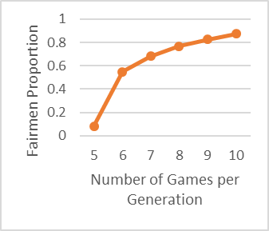

**Fig 5:** Final proportion of “Fairman” strategy varied over number of games per generation.

Since increasing the number of games per generation only serves to make more robust the previous results and increase the effect of reputation in a different manner, we see that more closely held reputations where each action has increased long-term consequences continually favors the emergence of the honorable ‘Fairman’ strategy.

These two synergistic effects of the reputation score formalize Robert Sapolsky’s descriptions of an “honor” culture, which are, in part, about “taking retribution after affronts to self, family, or clan, and reputational consequences for failing to do so. If they take your camel today and you do nothing, tomorrow they will take the rest of your herd”.3 This strongly matches the nature of the Ultimatum Game under a significant reputation bias (r > .75), and our simulations confirm the anecdotal explanations of Sapolsky and others as to how seemingly irrational responses to insults and unfair treatment can be sustainable and relatively universal. Indeed, throughout history, numerous leaders and statesmen have exhibited a willingness to sacrifice short-term gain to preserve their own reputation, especially if they feel the equivalent of the “unfair offer” to be an insult and a public signal to others on the international stage.4

In the standard version of the ultimatum game, evolutionary dynamics and rational choice theory fall short in explaining the empirical behavior observed across numerous cultures. The significant cultural variation has experimentally shown some society-wide acceptance of unfair offers, and the proposal (sometimes accompanied by rejection) of too-generous offers, where the proposer offers more than half of the good.5 Regardless of this variation, the full Gamesman strategy is never observed across entire societies (slightly unfair offers, such as 60-40 are commonly seen, however), and the implementation of reputation, even in this rather simplistic manner, provides a clear, consistent, and robust evolutionary explanation as to why the absence of sequential rationality persists. Factors that increase the impact of reputation in real societies include small group size, interdependence among fellow group members, and ability to gossip and transmit reputational information, all of which are highly prevalent in almost if not all prehistoric tribes and societies. By cultural evolution, a significantly reputation-based society will naturally evolve fairness norms as modelled in the Ultimatum Game. While it remains to be seen what the effects of reputation are on other games, we are now closer to a meaningful evolutionary account of human behavior in ultimatum bargaining.

Works Cited

1. Güth, Werner, et al. “An Experimental Analysis of Ultimatum Bargaining.” Journal of Economic Behavior & Organization, vol. 3, no. 4, Dec. 1982, pp. 367–388.
2. Henrich, Joseph & Boyd, Robert & Bowles, Samuel & Camerer, Colin & Fehr, Ernst & Gintis, Herbert. (2006). Foundations of Human Sociality: Economic Experiments and Ethnographic Evidence From Fifteen Small-Scale Societies.
3. Sapolsky, Robert M. *Behave:* the Biology of Humans at Our Best and Worst. Vintage, 2018.
4. Dafoe, A. (2012). *Resolve, Reputation, and War*: Cultures of Honor and Leaders' Time-in-Office. UC Berkeley. ProQuest ID: Dafoe_berkeley_0028E_12255. Merritt ID: ark:/13030/m59k7fsc. Retrieved from https://escholarship.org/uc/item/9v72937b
5. Skyrms, Brian. *Evolution of the Social Contract*. Cambridge University Press, 2014.